**Creating a System Support Map using an online tool *(Note: This is not the System Support Mapping Wizard)***

|  |  |  |  |  |  |
| --- | --- | --- | --- | --- | --- |
| Step | | How to do it | What this should look like | | |
| **Open the online tool**  A System Support Map (SSM) is a way of visualizing the different kinds of support you might use to work on a complicated challenge. Completing SSMs will support your own thinking about your objectives, needs, and resources. Specifically, SSMs walk individuals or organizations through the process of documenting their own role in a collaboration:   * how they are operationalizing that role in terms of specific responsibilities or project activities * what they need to succeed in meeting their responsibilities * specific resources they rely on (and an assessment of how supportive they are) * and their top three wishes to maximize success in their work.   Additionally, SSMs from partners can become the foundation for aligning efforts and setting priorities to collaborate efficiently.  ***If you would like to use the System Support Mapping Wizard, use this link:***  <http://syssci.renci.org/ssm-wizard/?module=TitleVWorkforce> | | Open **Google Chrome** to the [National Maternal and Child Health Workforce Development Center’s System Support Map (SSM) website](http://syssci.renci.org/ssm/) (<http://syssci.renci.org/ssm/>)  **Important! Do Not Use Internet Explorer, Firefox or Safari: they won’t work.**  A toolbox containing color bars and shapes will appear in the lower left-hand corner, and, in the center of the window, the system support rings: colored circles labelled “Role/Identity,” “Most Important Responsibilities,” etc.  NOTE: Click on the Help button in the toolbox – it’s got a question mark (“?”) on it – to see a list of the basic commands needed for building and navigating within your System Support Map. |  | | |
| **Role identification**  *Before starting to build your SSM, focus on a specific challenge. This could be a National Performance Measure you are targeting or a challenge you are facing within your organization. Please take a few minutes to develop a clear idea of the challenge you are attempting to map and your role in it.*  *How would you name your role in the work you are mapping?*  *Some possible roles are: project manager, care coordinator, service provider, health educator, or state public health leader.*  *If you have multiple roles that you want to explore, pick one. Each map is designed to look at one role and one role only. You can come back and fill out other maps for other roles later.* | | Draw a purple circle in the center of the map. In the toolbox, click on the circle shape and then click on the color purple: all shapes you create when these are selected will be purple circles.  First hold down the Shift key and then click your left mouse button (we’ll call this “**Shift-Click**”; the same process works on a Mac) in the middle of the purple inner ring to create a purple circle (with a default name of “Identity 1”). If the inside of the circle is pink, then it’s selected.  When you’ve created a new shape, the text inside should be selected and ready for editing. (If not, and at any time, you can select text inside a shape for editing by **Shift-Clicking** on it). Type in your role (e.g., Title V coordinator)  You can delete text using backspace or delete.  Delete a shape by clicking on the area so that it is highlighted in a color and then hitting your “delete” key. |  | | |
| **Describe your role**  *In addition to naming your role, please briefly describe the challenge you will focus on in this map.*  *Example responses might be: to facilitate integration of care coordination activities supporting children and youth with special health needs across the state, to support the social and emotional wellness of children aged 0-8, or to facilitate the implementation of Bright Futures (or another evidence-based intervention). If it helps, you can simply describe the challenge in terms of the outcome(s) you would like to improve.* | | In the toolbox, click on the shape called “no border” and keep the color purple selected.  **Shift-Click** just below your name/role to create a new shape with no border. Then edit the text inside (“text 1”; **Shift-Click** to select, if not selected) to type in additional descriptive info.  To move a shape, hold the left mouse button down on it and drag (“**Click-Drag**”), releasing the mouse button when the shape is where you want it. |  | | |
| **Identify your responsibilities**  *In your role, what do you see as the main activities you are responsible for?*  *Identify the 4-8 most important responsibilities related to this role and add them here.*  *Tip: For some people it makes more sense to describe relevant project activities, objectives or goals instead of responsibilities in this ring. As long as you are describing ways you invest your time related to the challenge you are mapping, the specific label doesn’t matter.* | | Make a list of the most pressing responsibilities that come to mind. Review the list and then reflect on what is missing from it. When you have a reasonably complete set of responsibilities, enter them into your System Support Map in the second (blue) ring. As follows:  Select blue rectangles. **Shift-Click** to create one rectangle per responsibility. Remember, default text may be selected for editing by holding down the Shift key while clicking on the default text.  Create arrows to each *responsibility* (the rectangles):  Select the solid arrow and the purple color bar.  Hold the Shift key down and press the mouse button down on the source shape, that is, the *role* (purple circle).  Continuing to hold the mouse button down, drag the mouse to a *responsibility* shape (a blue rectangle) until it is highlighted in light blue.  Release the mouse button over the target shape to create the arrow. This action is called “**Shift-Drag**.” | Use these options to create shapes with colors that correspond to the ring they are inside and add text | | |
| **Save Early and Often!**  There is currently no “Undo” function in this software, so remember to save frequently. We strongly recommend that you save each time into a separate file, and number them in order, so that you a) don’t overwrite and destroy a valid earlier version by mistake, and b) so you have a running record of your map-building process and can return to any stage in the building process. | | Important! To save your map, click on the square with the down arrow in the toolbox. If your browser settings are “Ask where to save each file before downloading” you’ll get a “Save As” dialog box.  Pick a location and a name so that you can find it later – we’ll call this file “Philip1.json” – and click the “Save” button.  There’s no Undo, so remember: “Save Early and Often!” |  | | |
| **Identify your needs**  *State the resources needed to support each of your indicated responsibilities.*  *Common needs include time, reimbursement, buy-in from your organization, and information. Please be creative here! The more comprehensive this list is the better. Be sure to consider personal needs, like patience, empathy, and creativity. You can be very specific, such as “I need access to a state car to conduct site visits” or more general, such as “I need guidance.”*  *You’ll be asked about each responsibility in turn, starting with the first one you entered. As you add needs, they will be entered into your map.*  *Tip: Needs are the ingredients in a recipe for how you get each responsibility done.* | | In the toolbox, change the selected color to aqua; and the selected shape to diamond.  In the next ring out from the center, labelled “General Needs for Each Responsibility,” create one or more diamonds for each *need*.  Link *responsibilities* to *needs* by selecting blue and the solid arrow in the toolbox, and **Shift-Drag** from a *responsibility* (rectangle) to the *need* (diamond) you want to link it to.  NOTE: continue to SAVE YOUR MAP in sequential order, updating the name of the file at each SAVE For example, the first time we saved this file we called it Philip1.json. We’ll call subsequent saved versions Philip2.json, Philip3.json, etc. (The file type is “.json” and it’s useful to include that extension, but it’ll still work without it.). |  | | |
| **Resources**  *Reflect for a moment about the needs you listed. What specific things, organizations, places, or people have you tried (whether or not they have helped you) to get that need met? Resources might include knowledge or strengths you or someone around you has, websites, brochures, training programs, public transportation, services in your community, providers, a case manager, local or national organizations, or books you read to build a skill in yourself.*  *When you are ready, enter information about each resource, one at a time. First, you will type the specific name or a short description of the resource. For example, you might type “Dr. Smith”* [*www.name_of_website.com*](http://www.name_of_website.com) *“my patience,” or “Tech Solutionz.”*  *A resource can help with one need, or with many needs – draw arrows from a resource to all the needs it supports. For example, time management skills are a resource that might help with many of your needs while a specific piece of equipment might only help with a single need that you listed.*  *Tip: Think creatively about resources! If needs are ingredients in a recipe, resources might include things like a favorite cookbook/recipe, particular brands of an ingredient, a store that sells everything you need on your grocery list in one stop, or a friend who makes cooking more fun!* | | Select **black** and oval. **Shift-Click** to create shapes and insert text for each *resource* you want to include.  Once you have created a *resource*, connect it to the appropriate *need[s]* (there may be several). To do this, select the desired color for an arrow. **Shift-Drag** from the *resource* (oval) to the corresponding *need* (diamond) to link them.  COLOR MATTERS: Choose the color of the link to help document how well the system is (or is not) supporting you. **Black** arrows are neutral (let’s say the resource was ok, not great but not bad). Use a green arrow to indicate a particularly helpful resource. Use red to indicate a resource that’s unhelpful or unavailable. You need to select the color before you create the link. If you create a link with the wrong color, just click on it to highlight it (it turns pink), hit “Delete,” and redo.  You may wish to write notes on the arrows about why certain resources were particularly helpful (or not). **Shift-Click** on the arrow’s default text (a number) to edit. |  | | |
| **Wishes**  *The area outside the outer “Available Resources” ring will incorporate the hopes and dreams you have for the person you support. Indicate here the factors that would create a “perfect world” and use arrows to show which (and how) existing resources and needs would be affected by a “wish come true.”* | | Select the color gold and the star shape in the toolbox.  **Shift-Click** outside the outer (black) ring to create shapes that represent your *wishes*.  Link them to the appropriate *resources*, *needs*, and *responsibilities* using arrows colored to show the likelihood that your wishes will be fulfilled: red for low probability, **black** for moderate or unknown, green for fair to high probability that your wish will be fulfilled. |  | | |
| **Equalizing shape size**  *If you would like to equalize the shapes on your System Support Map, please follow the instructions to the right.* | | NOTE: Be sure to save your map first, in case you don’t like the results of equalizing the shapes.  When adding text to shapes, the shape automatically “shrink-wraps” itself to fit around the text as closely as possible. As a result, you may have shapes of a certain type that vary in size. To make same shapes a consistent size: 1) Select that shape in the toolbox; 2) Press the “Options” button; 3) Select the first menu item “Equalize shape size…”; and 4) Select the first item -- “Equalize selected shape size” – from the submenu that appears.  All shapes of the same kind should now be of the same size: as wide as the widest, as tall as the tallest. You may want to rearrange the resized shapes to fit, because some of them may now be larger and may overlap other objects.  NOTE: To equalize the sizes of all shapes at once, go to the “Equalize shape size…” menu and select the *second* item in the submenu: “Equalize size for all shapes”.” This makes all shapes of each type the same size. |  | | |
| **Download or Upload a Map**  *You can download the map you just created to your computer, or you can upload a map to the SSM online tool.*  **Export your Map**  *If you would like to print your map, you need to export it as an image. Alternatively you can take a screenshot of your map in the online tool.* | To download, click on the square icon and a .json file will be downloaded onto your computer. The file will be wherever downloaded files are stored on your computer. Json files will seem like gibberish unless they are opened in this online tool.  To upload a .json file, click on the cloud icon. Find the .json file you would like to open in the online tool and select it.  To export you map as an image, click on the options button. Select “export map as image.”  TIP: Position your map so that it looks like the full map to the right before exporting as an image. You may need to reposition and export your map several times so that the resulting image is correctly sized. | | |  |

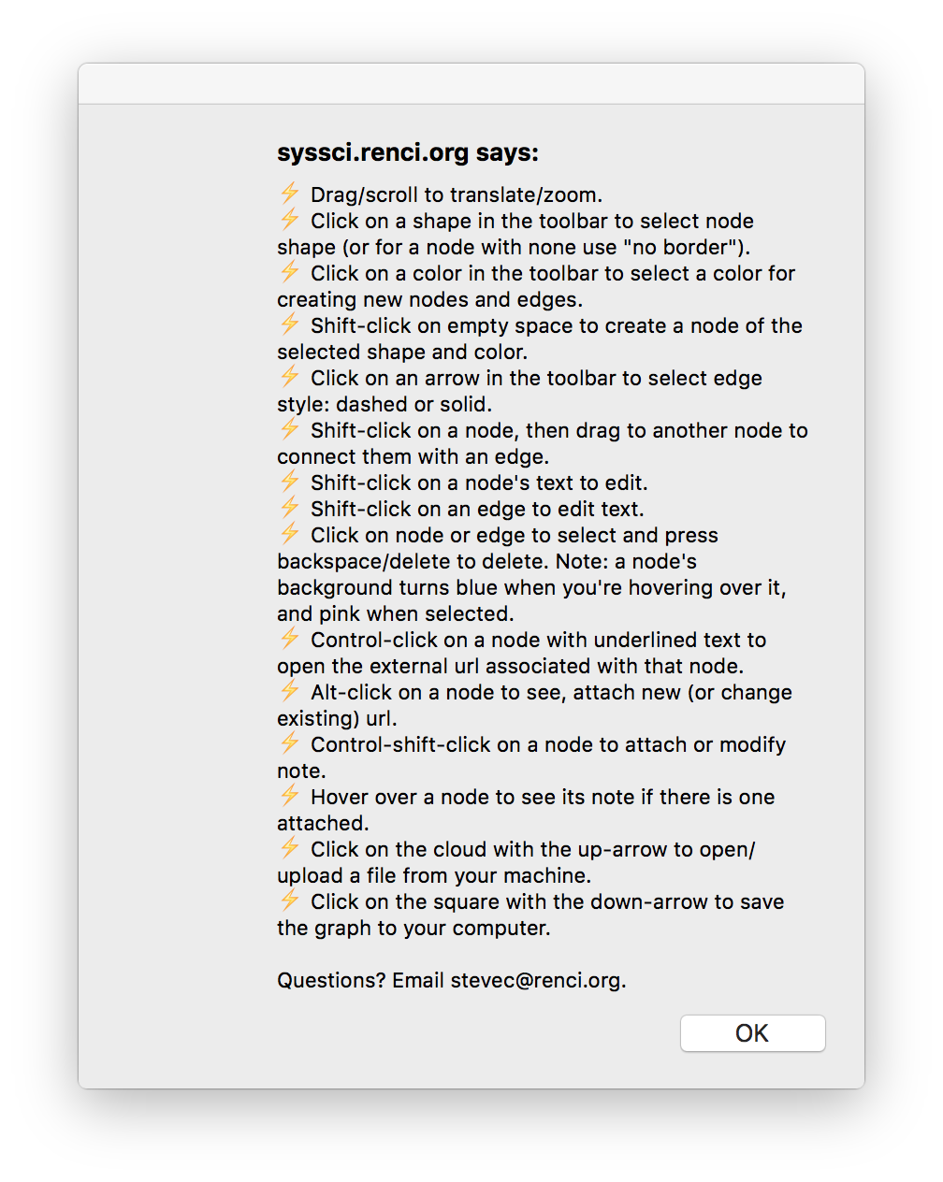 Click on the Help button – the button in the toolbox with the question mark (“?”) – to see the following list of commands:

